Article

**COMPREHENSIVE ASSESSMENT OF THE economically feasible AND BIOLOGICAL VALUE OF *COTONEASTER MELANOCARPUS FISCH. EX. BLYTT.* FOR THE Northern Kazakhstan**

*Dani SARSEKOVA1, Yedil AISHUK2*, Sara KITAIBEKOVA3, Sezai ERCİŞLİ4*, *Gaukhar SYZDYKOVA5*

*1 Kazakh National Agrarian Research University , Almaty 050000, Republic of Kazakhstan*

*2,3 S. Seifullin Kazakh Agrotechnical Research University, Astana 010000 / Bolashaq Saraiy, Kokshetau 020000, Republic of Kazakhstan*

*4 Ataturk University, Ankara 06000, Republic of Turkey*

*5 Sh. Ualikhanov Kokshetau University, Kokshetau 020000, Republic of Kazakhstan*

*\*Correspondence: edil_94.03@mail.ru; Tel.: +7-707-5175284*

**Abstract.** This article presents a study of the pharmacological value of Cotoneaster melanocarpus Fisch. ex. Blytt. according to the content of vitamin C (ascorbic acid). The fruits were harvested in the summer and autumn of 2022, in the state national parks of Kokshetau (Zerenda) and Burabay (Shchuchinsk). Chemical analysis was performed by titrimetry in the laboratory of biotechnology Bolashaq Saraiy.

The results of the study showed that the content of ascorbic acid in the fruits of Cotoneaster melanocarpus Fisch. ex. Blytt. affects the geographical factor of the place of growth of the cotoneaster and the time of harvesting. The maximum accumulation of vitamin C in raw materials is reached in late August - early September. Raw materials harvested in the northern part of the Akmola region are richest in vitamin C - 0.24 and in the fruits of the cotoneaster purchased in pharmacies amounted to 0.14%. A comparative analysis of the content of vitamin C in the fruits of woody and shrubby plants showed that Cotoneaster melanocarpus Fisch. ex. Blytt. is among the leaders in the content of ascorbic acid – 90 mg/100 g.

Investigation of bactericidal properties of wound phytoncides Cotoneaster melanocarpus Fisch. ex. Blytt. Akmola region showed that during the flowering period there was no increase in antimicrobial activity. During the summer period, when the intact leaves reached their normal size, they showed a high antimicrobial effect against test cultures. The peak of phytoncidal activity of the studied species was observed in the summer period (July - August) at the maximum of solar activity. In September, the greatest phytoncidal activity was noted in the Kokshetau State National Nature Park. Two peaks of phytoncidity have been established – in July and in early October, before the beginning of leaf flowering. A high correlation between phytoncidity and air temperature during the growing season was revealed in all samples (r = 0.86 – 0.67).

According to the results of a comparative analysis of the biological and decorative properties of some dogwood species, the advantages of Cotoneaster melanocarpus Fisch. ex. Blytt can be noted. according to the following set of external signs, the height of the plant, the density and closeness of the crown, the group of the physiognomic type, the decorativeness and density of the trunk and bark of the plant.

**Keywords:** Cotoneaster melanocarpus Fisch. ex. Blytt, phytoncides, woody plants, Staphylococcus aureus, bactericidal activity, decorative qualities, landscaping, vitamin C (ascorbic acid), woody plants, titremetry, biofarmation.

1. **Introduction**

Reducing the biological diversity of wild and economically valuable plants is one of the main environmental problems of our time. In Northern Kazakhstan, one of these species is the Cotoneaster melanocarpus Fisch. ex. Blytt, the value of which is determined by its medicinal, economic and decorative properties [[1]](https://cyberleninka.ru/article/n/razmnozhenie-invitro-kak-odin-iz-perspektivnyh-sposobov-sohraneniya-vida-cotoneastermelanocarpus-fisch-ex-blytt/viewer). Since ancient times, man has used healing springs of wildlife. The surrounding plant world served him not only as food and shelter: at the right moment, man used the healing properties of plants in the treatment of various diseases. Many folk observations accumulated over the centuries are still far from being studied today [[2]](https://cyberleninka.ru/article/n/kratkiy-ocherk-istorii-fitoterapii/viewer).

Vitamins play one of the key regulators of biochemical processes in the human body. A number of scientists have studied the content of vitamin C in the fruits of woody plants, the highest content of vitamin C is observed in the fruits of lemon, currant, apple, sea buckthorn, cranberry, raspberry [[3]](https://cyberleninka.ru/article/n/rol-plodov-i-yagod-v-obespechenii-cheloveka-zhiznenno-vazhnymi-biologicheski-aktivnymi-veschestvami/viewer). The high content of vitamin C in the fruits of Cotoneaster melanocarpus Fisch. ex. Blytt is known from literary sources, but there are no laboratory results to date, and therefore the study of the chemical nature of vitamin C in the fruits of this woody plant and the elucidation of the mechanism of biological action are relevant [[4]](https://link.springer.com/article/10.1007/s11627-023-10332-w).

Forest air is very good for health, and one of the most important reasons for this is the presence of phytoncides in it, which kill or suppress pathogens and have a healing effect. Do not think that by releasing phytoncides, plants take care of our well–being - they protect themselves first of all. In his book "Medicinal poisons of plants. The Tale of phytoncides" (1928-1930). The creator of the doctrine of phytoncides, Doctor of Biological Sciences B.P. Tokin describes the bactericidal properties of plant substances [[5]](https://djvu.online/file/dnIPOt7yMngjU) . The term “phytoncides” means that these substances are of plant origin ("phyton" is a plant and that they have the property of killing other organisms (indicates a particle of "cyde") [[6]](https://www.researchgate.net/publication/280575119_Forests_air_pollution_and_water_quality_Influencing_health_in_the_headwaters_of_Central_Europe's_Black_Triangle).

In addition to the author of this book, A.G. Filatova and A.E. Tebyakina were the first in studying field of phytoncides, who, under the leadership of B.P. Tokin, convincingly proved the powerful bacteriocaying properties of phytoncides of food plants against bacteria pathogenic to humans. The problem of phytoncides has become the property of science, and many specialists in different countries are engaged in it [[7]](https://www.mdpi.com/2076-3417/12/9/4495)

Kushnarenko S.V., Utegenova G.A., Shegebaeva A.A., Danilova A.N., Kazakh researchers of the Institute of Biology and Biotechnology in Almaty established antimicrobial properties of phytoncides of 9 species of endemic plants of plants of Kazakhstan [[8]](https://www.researchgate.net/publication/317597063_Antimikrobnaa_aktivnost_efirnyh_masel_nekotoryh_rastenij_Kazahstana).

The study of phytoncidal properties of plants has become widespread in the light of global greening and urban improvement.

For example, in studies of the phytopathological state of stands in recreational areas of Astana, A.A. Dzhumagulov notes the high phytoncidity of scots pine, under the influence of essential oils of which the air in the plantings is ionized, and some pathogenic bacteria (staphylococci) die [[9]](https://kazatu.edu.kz/webroot/js/kcfinder/upload/files/наука/СЧ-18/Джумагулов%20А.А.%20.pdf).

Phytoncidal activity of tree species of the green zone of the city of Astana, expressed as a percentage of the suppression of E.Coli culture, has the following values: common pine - 100%, Siberian larch - 57%, common spruce - 58%, warty birch - 59%, balsamic poplar - 43%, summer oak - 45% [[10]](https://cyberleninka.ru/article/n/sozdanie-lesnyh-kultur-v-zelenoy-zone-g-nur-sultan-na-pochvah-razlichnoy-lesoprigodnosti/viewer)

Studies of the phytoncidal properties of woody and shrubby plants, including dogwood, have been poorly studied. Mention of the bactericidal properties of the Cotoneaster lucidus are found in the works of G. V. Delova (1967), the author notes the high bactericidal activity of crushed leaves throughout the growing season to Staphylococcus aureus [[11]](https://nsu.ru/xmlui/bitstream/handle/nsu/4575/08.pdf?sequence=1&isAllowed=y). Studies of the phytoncidity of the Cotoneaster plant can be considered relevant due to the decorative and landscaping properties of the shrub and the possibility of its introduction into the practice of landscaping and landscaping of cities [[12]](https://www.researchgate.net/publication/327400564_Phytoncide_activity_of_woody_plants_under_the_conditions_of_steppe_zone).

Among the Cotoneaster family there are deciduous, evergreen and semi-evergreen species. In May, Cotoneaster is one of the most visited honey plants by bees. Bees on Cotoneaster are usually much more numerous than on horse chestnut, mountain ash. In June, the attendance of bees in the dogwoods increases, reaching a maximum. Honey-bearing properties of Cotoneaster melanocarpus Fisch. ex. Blytt has been studied a little, but this species is most widespread in Northern Kazakhstan [[13]](https://kazatu.edu.kz/webroot/js/kcfinder/upload/files/наука/СЧ-18(2)/Айшуқ%20Е.Ж.%2CСарсекова%20Д.Н..pdf).

The purpose of the study: Comprehensive assessment of the economically feasible and biological value of Cotoneaster melanocarpus Fisch. ex. Blytt.) for the Northern Kazakhstan.

Research objectives:

1. Determine the vitamin C content in the fruits of Cotoneaster melanocarpus Fisch. ex. Blytt.

2. To study the bactericidal properties of wound phytoncides Cotoneaster melanocarpus Fisch. ex. Blytt. in natural and man-made conditions of Northern Kazakhstan.

3. To evaluate the biological and decorative properties of Cotoneaster melanocarpus Fisch. ex.) Blytt. in landscaping on the example of Astana.

Object of research: plants, fruits and leaves of Cotoneaster melanocarpus Fisch. ex. Blytt. dogwood of the black-fruited Northern Kazakhstan.

Subject of research: Vitamin C and its mechanisms of biological action, bactericidal and economic properties of Cotoneaster melanocarpus Fisch. ex. Blytt. like a honey plant.

Scientific novelty and practical significance: a comprehensive assessment of the economic and biological value of Cotoneaster melanocarpus Fisch. ex. Blytt. In the conditions of Northern Kazakhstan, it is held for the first time. The research has practical significance in the preservation and popularization of the woody plant and the use of this biological species in all sectors of public use.

Research methods: Vitamin C content was determined by titrimetric method [[14]](https://www.researchgate.net/publication/313964413_Vitamin_C_contents_of_tropical_vegetables_and_foods_determines_by_voltammetric_and_titrimetric_methods_and_their_relevance_to_the_medicinal_uses_of_the_plants). The essence of the titrimetric method is that 2,6-dichlorophenolindophenol acts not only as an oxidizer, but also as an indicator by which the end of titration is determined. The color of the solution of 2,6-dichlorophenolindophenol depends on the pH of the medium, and when it is restored, it turns into a leucoform (Figure 1.)

|  |
| --- |
| Oxidized form of the indicator |
|  |
| In an alkaline environment – blue color In an acidic environment – red color |
| The restored form of the indicator. Leucoform. |

Figure 1. Redox forms of the indicator with the titrimetric method for determining vitamin C.

Quantitative determination is carried out by adding an alkaline solution of Tilmans paint to an acidified solution containing vitamin C. While the titrated solution contains vitamin C, the added solution of 2,6-dichlorophenolindophenol, which has a deep blue color, discolors with the formation of a leucoform (indicator), due to the presence of a reduced form of ascorbic acid [[15]](https://www.researchgate.net/publication/290008760_A_new_kind_of_high-performance_alkaline_paint_stripper_for_tinplate).

As soon as the entire amount of ascrbic acid in the analyzed solution is oxidized to dehydroascorbic acid, the solution acquires a red color characteristic of the oxidized form of 2,6-dichlorophenolindophenol in an acidic medium. The method is standardized (State Standard 30627.2–98 – Methods of measuring the mass fraction of vitamin C) [[16]](https://www.mdpi.com/1999-4907/10/2/86).

Analysis progress. The exact weight (about 5-10 g) of the pre-crushed test material should be placed in a porcelain mortar. Add 20 ml of 1% hydrochloric acid solution in small portions, carefully rubbing the sample until a homogeneous slurry is obtained. The mixture should be quantitatively transferred to a 100 ml volumetric flask (the total volume of hydrochloric acid should not exceed 50 ml). Rinse the mortar and pestle with a 1% solution of oxalic acid and collect the flushes in the same measuring flask. Bring the volume of the solution to the mark with a solution of oxalic acid.

Mix the contents of the flask and after 5 minutes filter through a folded filter into a dry flask or centrifuge. The resulting filtrate or fugate in an amount of 1-10 ml (depending on the vitamin content) should be pipetted into a conical flask and bring the volume of the solution with distilled water to 15 ml. The analyzed solution should be titrated from a 0.001 N microburet with a solution of 2,6-dichloro-phenylindophenol until pink staining appears, which does not disappear within 30-60 seconds. Figure 2.

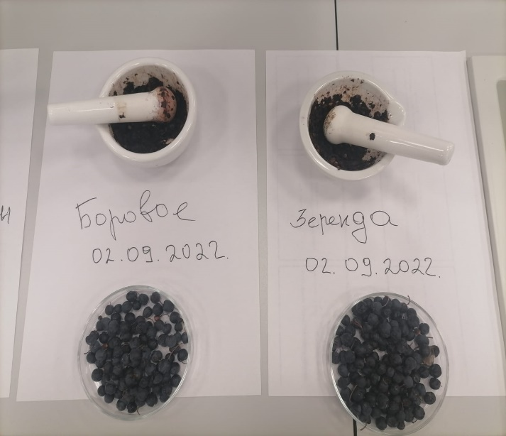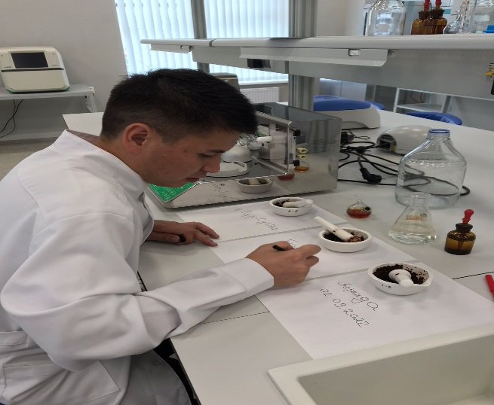

Figure 2. Preparation of samples for analysis

Control experience 1. To assess the correction for the presence of other reducing substances in the reagents used, add 0.1 ml of a 10% solution of copper sulfate to 10 ml of filtrate or fugate and keep at a temperature of 110 0C for 10 minutes to decompose ascorbic acid. After cooling, add 5 ml of distilled water and titrate the analyzed solution from a 0.001n microburet with a solution of 2,6-dichlorophenolindophenol. For a titrated volume of 15 ml, the volume of the titrant used for the control experiment is usually 0.04–0.06 ml. This correction must be subtracted from the volume of the titrant used for titration of the prototype. Calculate the mass fraction of ascorbic acid (САА, mg %) in the analyzed material by the formula

CAА=T×V1×V2m×V3×100,

where T – is the titer of 0.001 n of a solution of 2,6-dichlorophenolindophenol by ascorbic acid, 0.088 mg/ml;

V1 – is the volume of 0.001 n of a solution of 2,6-dichlorophenolindophenol used for titration of the extract, adjusted for reagents, ml;

V2 – the total volume of the extract, 100 ml;

V3 – is the volume of the extract taken for titration, 15 ml;

m – is the weight of the sample of the test material, g;

100 – conversion factor per 100 g.

Phytoncidal activity of Cotoneaster melanocarpus Fisch. ex. Blytt. The test cultures of gram-positive Bacillus Subtilis IMB B7018 and gram-negative Esherichia coli UKM B-926 microorganisms were determined by the method of "fermentation". A number of grown colonies was calculated in Petri dishes with plant material and relative to the control, the degree of inhibition of the test culture was determined [[17]](https://cyberleninka.ru/article/n/fitontsidnaya-aktivnost-drevesnyh-rasteniy-v-usloviyah-urbanizirovannoy-sredy-na-primere-g-donetska/viewer).

Control experiment 2. Whole leaves (3 g) were placed on a lid, which was covered with a cup with crops on top, excluding contact of the leaves with the nutrient medium.

Cups with plant material were kept for 4 hours in daylight at room temperature. Then the cups were placed in a thermostat at 37 ° C for a day, and a number of colonies was counted the next day. The materials were collected monthly in sunny, windless weather during the growing season of 2022. Healthy, intact leaves, without signs of chlorosis, were selected for the experiment along the entire perimeter of the crown (from the southern, northern, eastern and western parts), from the lower tier. Leaves were collected from 10 trees of each species to obtain an average sample. During sampling, meteorological measurements (illumination, temperature and humidity), as well as visual phenological observations were carried out.

Control experiment 3. Viability and decorativeness of woody plants were determined by the condition of the crown and trunk, the presence of lichens on it, evaluated in points on the scale of L.S. Savelyeva [[18]](https://zenodo.org/record/2278437).

Control experiment 4. The number of honey plants and the number of flowers on plants was determined by the method of continuous coating in densely growing areas of the studied species [[19]](https://www.bio-conferences.org/articles/bioconf/abs/2021/11/bioconf_mtsitvw2021_01008/bioconf_mtsitvw2021_01008.html).

Mathematical data processing was carried out by methods of descriptive statistics and variance two-factor analysis, followed by evaluation of differences by the Dunnet and Duncan method, using the Statistica 6.0 package and MS Excel [[20]](https://bjo.bmj.com/content/bjophthalmol/82/9/1003.full.pdf).

Results and their discussion. *Content vitamin C in Cotoneaster melanocarpus Fisch. ex. Blytt fruits.* One of the plant sources of vitamin C intake into the human body and use in pharmacology can be the fruits of Cotoneaster melanocarpus Fisch. ex. Blytt [[21]](https://npsochi.ru/upload/iblock/3c1/yn5l1ijfm7jqmsr11yivc42z1drztkdo.pdf). By the end of August, the fruits of the dogwood melanocarpus Fisch (Cotoneaster melanocarpus Fisch. ex. Blitt acquire a bright brown color, full ripening occurs in late September - early October, the fruits turn from brown to black Fig. 3-4 [[22]](https://www.mdpi.com/1999-4907/10/11/951).

|  |  |
| --- | --- |
|  |  |
| Figure 3. Dark brown fruits of the Cotoneaster melanocarpus Fisch. ex. Blytt end of summer, Zerenda village of Akmola region | Figure 4. Ripe fruits of Cotoneaster melanocarpus Fisch. ex. Blytt in autumn, Zerenda village, Akmola region |

The results of laboratory studies have shown a high concentration of ascorbic acid in the fruits of dogwood prunus table 1.

On average, the content of vitamin C in the fruits of the Cotoneaster melanocarpus Fisch. ex. Blytt harvested in the village of Zerenda, Akmola region at the beginning of August made up 0.19%, in the autumn period at full maturity – 0.22%.

In the resort area of Shchuchinsk, the content of vitamin C in the fruits of the black–fruited dogwood was significantly lower, at the end of summer - 0.14%, and in autumn – 0.19%. In the raw materials, the manufacturer of the EuroFarma pharmacy "Zerde-Phyto" LLP, the vitamin C content is insignificant – 0.14%.

Table 1. The results of the study of crushed fruits of Cotoneaster melanocarpus Fisch. ex. Blytt. blackfruit according to the indicator "Quantitative determination".

|  |  |  |  |  |
| --- | --- | --- | --- | --- |
| № | Objects of research | Fruit picking time | The content of ascorbic acid in % | Conclusion |
| 1. | Fruits of the Cotoneaster melanocarpus Fisch. ex. Blytt 100 g., Kazakhstan, Zerenda village, Akmola region | early August | 0,19  0,18  0,19  0,20  0,19 | meet the requirements of  KNMF* |
| 2. | Fruits of the Cotoneaster melanocarpus Fisch. ex. Blytt 100 g ., Kazakhstan, Shchuchinsk, Akmola region | early August | 0,14  0,15  0,15  0,13  0,13 | don’t meet the requirements of  KNMF |
| 3. | Fruits of the Cotoneaster melanocarpus Fisch. ex. Blytt 100 g., Kazakhstan, Zerenda village, Akmola region | early September | 0,22  0,20  0,24  0,22  0,22 | meet the requirements of  KNMF |
| 5. | Fruits of the Cotoneaster melanocarpus Fisch. ex. Blytt 100 g ., Kazakhstan, Shchuchinsk, Akmola region | early September | 0,21  0,18  0,21  0,20  0,19 | meet the requirements of  KNMF |
| 6. | Fruits of the Cotoneaster melanocarpus Fisch. ex. Blytt 100 g ., manufacturer  Zerde-Phyto LLP  EuroFarma Pharmacy | Date of manufacture  15.10.2021  Shelf life 2 years | 0,14  0,13  0,15  0,12  0,16 | don’t meet the requirements of ~~not~~  KNMF |

*KNMF – Kazakhstan National Medicinal Formulary

The results of the study showed that the content of ascorbic acid in the fruits of the Cotoneaster melanocarpus Fisch. ex. Blytt is influenced by the geographical factor of the place of growth of the Cotoneaster and the time of harvest. The maximum accumulation of vitamin C in raw materials is reached in late August, early September. Thus, the fruits of the Cotoneaster melanocarpus Fisch. ex. Blytt collected in July in Shchuchinsk, Akmola region (Figure 5) contain only 0.14% ascorbic acid, and in early September its content increased to 0.05%, it is also worth noting that the level of vitamin C content can be influenced by anthropogenic and recreational load on the landscape and the natural environment of the plant.

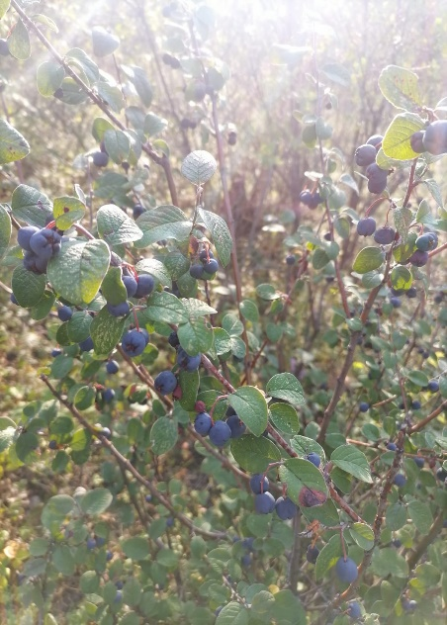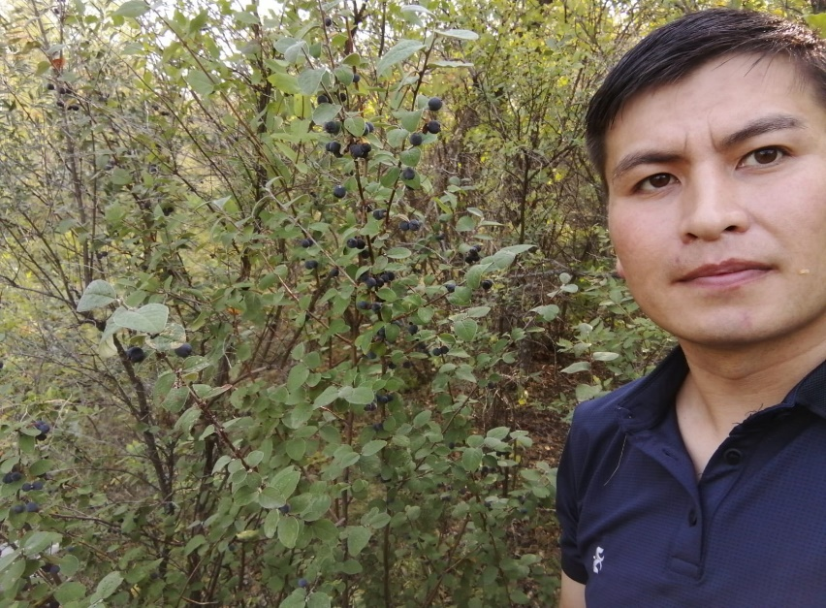

Figure 5. Collecting the fruits of the Cotoneaster melanocarpus Fisch. ex. Blytt

A comparative analysis of the vitamin C content in the fruits of woody and shrubby plants showed that Cotoneaster melanocarpus Fisch. ex. Blytt is among the leaders in ascorbic acid content - 90 mg/ 100 grams of fruit and is second only to rosehip – 220 mg/100 grams and black currant 200 mg/100 grams (Figure 6).

However, according to this indicator, it surpasses such woody plants as apple, cranberry, raspberry, lemon and sea buckthorn by 1.5-2 times.

Figure 6. Vitamin C content in some woody and shrubby plants, mg/100 grams.

Based on the laboratory data obtained, it follows that the fruits of Cotoneaster melanocarpus Fisch. ex. Blytt are a valuable source of vitamin C and can be used in the pharmaceutical industry.

*Phytoncidal activity.* Seasonal dynamics of changes in phytoncidal activity was established for the studied species of woody plants (Table 2).

In the spring period, antimicrobial properties of volatile organic substances of swollen buds of Cotoneaster melanocarpus Fisch. ex. Blytt. they were lower compared to young leaves. In the future, as the leaves grew, the phytoncidal activity increased, since, in general, the release of volatile organic substances by plants depends on growth processes and the intensity of photosynthesis [[23]](http://zhreserve.ru/wp-content/uploads/2020/04/Кизильник-черноплодный-Cotoneaster-laxiflorus-J.-Jacq.-ex-Lindl.-C.-melanocarpus-Fisch.-ex-Blytt-категория-5.pdf).

There was no increase in antimicrobial activity during the flowering period. During the summer period, when the intact leaves reached their normal size, they showed a high antimicrobial effect against test cultures. The peak of phytoncidal activity of the plant was observed in the summer period (July - August) at the maximum of solar activity. In September, the greatest phytoncidal activity was noted in the village of Zerenda, Akmola region. Two peaks of phytoncidity have been established – in July and in early October, before the beginning of leaf flowering. A high correlation between phytoncidity and air temperature during the growing season was revealed in all samples (r = 0.86 – 0.67).

Table 2. Seasonal phytoncidal activity (%) of Cotoneaster melanocarpus leaves Fisch. ex. Blytt.

|  |  |  |  |  |  |  |
| --- | --- | --- | --- | --- | --- | --- |
| Variant | Test microorganisms | | | | | |
| *Bacillus Subtilis IMB B-7018* | | | *Esherichia coli УКМ В-926* | | |
| spring | summer | autumn | spring | summer | autumn |
| M±m | | | | | |
| Нighway  Shchuchinsk-Astana | 71,2±2,27 | 74,5±1,77 | 69,8±2,12 | 73,1±1,22 | 78,7±2,44 | 74,9±1,29 |
| Shchuchinsk, Akmola region | 75,6±1,37 | 81,2±2,33 | 71,2±2,36 | 71,6±2,33 | 78,2±1,47 | 74,6±1,44 |
| Zerenda village, Akmola region | 71,2±2,37 | 77,2±1,56 | 74,3±3,2 | 71,2±2,33 | 81,2±2,14 | 80,2±2,14 |
| Astana, Yanushkevich str. | 76,2±1,2 | 81,2±2,11 | 80,2±2,1 | 77,4±2,3 | 84,2±2,17 | 80,2±3,14 |

*\* Note: M ± m is the arithmetic mean and the error of the mean; the differences compared to the control are significant at P≥0.95(*), P≥0.99 (**), P≥0.999 (***).*

All studied plant samples, depending on the degree of phytoncidal activity, were divided into 4 groups: with very high phytoncidal activity from 81 to 100%, high – from 61 to 80%, medium – from 45 to 60% and low – from 0 to 44%. Analysis of the specific features of the release of volatile organic substances by the leaves of the studied plants in various types of plantings showed that in the summer period, the leaves of the dogwood in all areas had the greatest antimicrobial effect on Bacillus Subtilis colonies. Near the source of pollution – the highway, this species showed very high phytoncidal activity, in the control it was assigned to the group with high phytoncidity. The degree of antimicrobial activity of a plant depends not only on its species and phenological phase, but also on the vital state of the plant organism [[24]](https://www.mdpi.com/1999-4907/11/6/705).

Shrubs growing near the highway had the beginning of drying of the apical growth and necrosis of the leaves. It should be noted that most of the leaves, especially on the variant of plant samples of the city of Astana, A.Yanushkevich St., were affected by chlorosis (Table 4).

In stressful growing conditions, with a decrease in the vital signs of the shrub, its protective mechanisms are activated. Antimicrobial substances are one of the factors of plant immunity, therefore, phytoncidal activity increases in shrubs with limited viability. However, with mass drying of skeletal branches and complete drying of the crown, the release of volatile organic substances stops [[25]](https://www.mdpi.com/1999-4907/11/6/627).

Table 4. Phytoncidal activity (%) of Cotoneaster melanocarpus leaves Fisch. ex. Blytt.

|  |  |  |  |  |  |
| --- | --- | --- | --- | --- | --- |
| *№* | Variant | Time to increase the activity of protozoa, min | Time to slow down the movement of protozoa, min. | Time of death of protozoa, T, min. | Phytoncidal activity of protozoa, A % |
| *1* | Сontrol | 0,5 | 0,65 | 1,49 | 67,1 |
| *2* | Нighway  Shchuchinsk-Astana | 0,22 | 1,25 | 2,78 | 35.9 |
| *3* | Shchuchinsk, Akmola region | 0,25 | 2.21 | 3,0 | 33,3 |
| *4* | Zerenda village, Akmola region | 0,48 | 0,88 | 2,15 | 46.5 |
| *5* | Astana, Yanushkevich str. | 0,68 | 1,0 | 2,34 | 42,7 |

A two-factor analysis of variance showed that the phytoncidal activity of the dogwood is significantly influenced by: the season (significance level P=1.7 *10-5) and a set of growing conditions (significance level P=2.7*10-4). Volatile organic substances of the leaves of the studied species differently inhibited the growth of colonies of test cultures. For the studied species, there was a tendency to greater antimicrobial activity in relation to the gram-negative bacterium Esherichia coli *УКМ В-926* compared with Bacillus Subtilis IMB B-7018.

*Biological and decorative properties of Cotoneaster plants.* The growing conditions of shrubs determine their life expectancy [[26]](https://www.mdpi.com/1999-4907/11/6/663). Urban ecology and buildings, dust pollution, automobile exhaust, soil depletion, an increase in asphalt and concrete pavement coverings greatly reduce the life expectancy of ornamental plants. On average, the life expectancy of all three species of the Cotoneaster genus ranges from 40 to 60 years (Table 5).

The ability of shrubs to restore trunks from damage and deformations and their durability is especially important for gardening and protective green spaces, according to this indicator, the genus of Cotoneaster belongs to the durable [[27]](https://www.mdpi.com/1999-4907/11/6/616).

The height of the Cotoneaster lucídus shrub is 100-200 cm, which is a relatively good option for decorative gardening of the middle tier, to create a complete dense planting, it is necessary to use other types of plant decor both on the lower and upper tiers. The height of the Cotoneaster horizontalis shrub is 50-100 cm, it is optimally suited for landscaping the lower tier of the hedge, however, this species, unlike its relatives, does not lend itself well to shearing and decoration [[28]](https://www.mdpi.com/1999-4907/11/6/706).

Table 5. Biological properties and decorative qualities of Cotoneaster shrubs.

|  |  |  |  |  |
| --- | --- | --- | --- | --- |
| № | The totality of external signs | Cotoneaster lucídus | Cotoneaster horizontalis | Cotoneaster melanocarpus Fisch. ex. Blytt |
| 1 | Life expectancy, year | 40-60 years | 40-60 years | 40-60 years |
| 2 | Debt Group | long-lasting | long-lasting | long-lasting |
| 3 | Plant height | 100-200 cm | 50- 100 cm | 100-300 cm |
| 4 | Crown diameter | 2-3 м | 0,5-1 м | 2-3 м |
| 5 | Crown density | tight | average tight | tight |
| 6 | Group by physiognomic type | Garden type | Dry pine forests | Pine forests+mountain alpine |
| 7 | Trunk and bark | Rough, brown with a touch | Rough, gray-brown | Naked, shiny, red-brown |

The ideal option for creating a hedge or decorative landscaping is Cotoneaster melanocarpus Fisch. ex. Blytt. height from 100 to 300 cm. According to the parameters of the diameter and density of the crown, the brilliant and black-fruited dogwood have the same parameters of 2-3 meters, high closeness and density. According to the physiognomic type, all three types of dogwood are different: Cotoneaster lucídus – garden type, Cotoneaster horizontalis – type of dry pine forests, black–fruited dogwood – type of pine and mountain-alpine forests [[29]](https://www.mdpi.com/1999-4907/11/6/605).

According to the degree of decorativeness of the trunk and bark of the shrub, the most acceptable is the black-fruited dogwood. The bark is bare without roughness, brilliantly red-brown in color, shiny and horizontal dogwood is rough with brown and gray-brown coating, respectively.

*Honey-bearing properties.* (Cotoneaster melanocarpus Fisch. ex. Blytt.) belongs to the Rosaceae family. It reaches 1.5 m in height and forms a densely branched bush. The leaves are elliptical or inversely ovate, rounded at the top, dark green, light from below. The flowers are small, pale pink, collected in three-flowered shields, the calyx is slightly pubescent [[30]](https://redbook56.orenlib.ru/rastenija/kizilnik-chernoplodnyj-cotoneaster-melanocarpus-fisch-ex-blytt.html). Blooms in May-June for 17-28 days. The flower secrete nectar for two days (Figure 7).

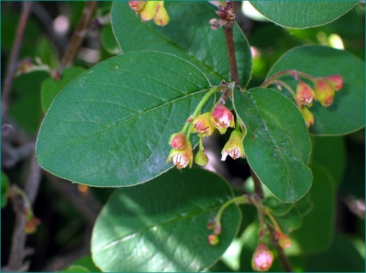

Figure 7. Flowering of the Cotoneaster melanocarpus Fisch. ex. Blytt.

During the flowering period, bees willingly visit the Cotoneaster melanocarpus Fisch. ex. Blytt. flowers, lingering on one flower for a long time. Nectar is released abundantly and fills the corolla of the flower sometimes by one third. The greatest attendance of the dogwood was noted between 10 and 12 o'clock in the afternoon. At this time, about 140 working bees can be counted on 1 sq.m of the plant for one minute. One flower secretes 0.505 mg of sugar per day. Honey productivity - 160.2 kg/ ha.

Unlike many other honey plants, Cotoneaster melanocarpus Fisch. ex. Blytt. intensively secretes nectar under different weather conditions. On average, the sugar content of nectar is 16.8—19.5%. On some days it varies — from 7.2% to 31.8%, caused by changes in environmental conditions. Short-term weather fluctuations have little effect on the sugar content of nectar, but long-term changes cause either a decrease in the percentage of nectar (a number of cloudy days with precipitation and air temperature 15-19 ° C), or its increase (warm, sunny days with air temperature 25-28 ° C). The highest sugar content in the nectar of flowers of the second day of life (on average 20-22%), slightly less — flowers of the first day (16-18%) and buds (10-14%). One hectare of plantings of the black—fruited dogwood allocates 706.8-1215.2 kg of nectar, which contained 122.3—204.2 kg of sugar (Figure 8).

Figure 8. Nectar excretion in flowers, some types of Cotoneaster melanocarpus Fisch. ex. Blytt. per day, mg.

Cotoneaster melanocarpus Fisch. ex. Blytt. in the conditions of the middle band, it has excellent properties of a honey plant. Planting Cotoneaster can significantly increase the honey reserves of the area.

Cotoneaster melanocarpus Fisch. ex. Blytt was introduced into culture in the XIX century and is cultivated throughout the European part, in the Urals, in Western Siberia, Central Asia, Altai and the Far East. It is considered the best of shrubs for trimmed hedges. It is hardy and bears fruit everywhere. At the age of 13, the plant reaches three meters in height, and then the density of branching and the width of the bush increase [[31]](https://природаэвенкии.рф/content/cotoneaster-melanocarpus-fischer-ex-blytt-1844-кизильник-черноплодный).

Cotoneaster melanocarpus Fisch. ex. Blytt can be propagated by seeds, layering and cuttings. The seeds have a long dormant period, so their germination is low. Sown in the ground in the spring, they germinate only the next year, and immediately after collecting them in the fall, they give unfriendly shoots two or three months after the onset of spring. To ensure their good germination, seed stratification is used (exposure to low or elevated temperatures on seeds in a humid environment) [[32]](https://www.researchgate.net/publication/5914973_Effect_of_cold_stratification_treatments_on_germination_of_drought_tolerant_shrubs_seeds).

They are stratified in peat for 11-12 months and sown in autumn, while receiving friendly shoots. In the studies of foreign scientists Iyyakkannu Sivanesan, Ju Yeon Song, and others, the importance of microclonal reproduction of some species of Cotoneaster is noted . Good results are obtained by spring sowing of seeds stratified for seven months. The first four months at the same time adhere to a temperature of 20-25 ° C, three months — 3-5 ° C, in the basement [[33]](https://link.springer.com/article/10.1007/s11240-010-9841-2).

Conclusion. The results of the study showed that the content of ascorbic acid in the fruits of Cotoneaster melanocarpus Fisch. ex. Blytt is influenced by the geographical factor of the place of growth and the time of harvest. The maximum accumulation of vitamin C in raw materials is reached in late August, early September. Thus, the fruits of the black-fruited dogwood collected at the end of summer in the village of Zerenda, Shchuchinsk contain only 0.16% ascorbic acid, and in early September its content increased to 0.27%.

All studied plant samples, depending on the degree of phytoncidal activity, were divided into 4 groups: with very high phytoncidal activity from 81 to 100%, high – from 61 to 80%, medium – from 45 to 60% and low – from 0 to 44%. Analysis of the specific features of the release of volatile organic substances by the leaves of the studied plants in various types of plantings showed that in the summer the leaves of Cotoneaster melanocarpus Fisch. ex. Blytt had the greatest antimicrobial effect on Bacillus Subtilis colonies in all areas. Near the source of pollution – the highway, this species showed very high phytoncidal activity, in the control it was assigned to the group with high phytoncidity.

According to the results of a comparative analysis of the biological and decorative properties of some Cotoneaster species, the advantages of Cotoneaster melanocarpus Fisch. ex. Blytt can be noted according to the following set of external features: plant height, crown density and closeness, physiognomic type group, decorative and density of the trunk and bark of the plant.

Unlike many other honey plants, Cotoneaster melanocarpus Fisch. ex. Blytt intensively secretes nectar under different weather conditions. On average, the sugar content of nectar is 16.8—19.5%. On some days it varies — from 7.2% to 31.8%, caused by changes in environmental conditions. Short-term weather fluctuations have little effect on the sugar content of nectar, but long-term changes cause either a decrease in the percentage of nectar (a number of cloudy days with precipitation and air temperature 15-19 ° C), or its increase (warm, sunny days with air temperature 25-28 ° C). The highest sugar content in the nectar of flowers of the second day of life (on average 20-22%), slightly less — flowers of the first day (16-18%) and buds (10-14%). One hectare of Cotoneaster melanocarpus Fisch. ex. Blytt plantings secretes 706.8—1215.2 kg of nectar, which contained 122.3—204.2 kg of sugar.

References

1. Serofimovich M.; Kirillov V.; Stihareva T. Razmnozhenie In vitro kak odin iz perspektivnyh sposobov sohraneniya vida vida Cotoneaster melanocarpus Fisch. ex. Blytt / Byulleten gosudarstvennogo Nikitskogo parka, 2020. // Vypusk №137 str. 67-75, <https://doi.org/10.36305/0513-1634-2020-137-67-75> ;
2. Petrushkina N.; Zhukovskaya E. Kratkij ocherk istorii fitoterapii / Zhurnal: Pediatricheskij vestnik Yuzhnogo Urala // Vypusk№ 1, 2018, str. 64-70;
3. Akimov M.; Makarov V.; Zhbanov E. Rol plodov i yagod v obespechenii cheloveka zhiznenno vazhnymi biologicheski aktivnymi veshestvami / urnal: Dostizheniya nauki i tehniki Agro-promyshlennogo kompleksa. 2019. T. 33. №2 <https://doi.org/10.24411/0235-2451-2019-10214>;
4. Kirillov V.; Pathak A.; Patel S.R.;  et al. Micropropagation of Cotoneaster melanocarpus Fisch. ex A.Blytt: an economically important ornamental plant. In Vitro Cell. Dev. Biol. - Plant 59, 147–153 (2023). <https://doi.org/10.1007/s11627-023-10332-w>;
5. Tokin B. P. Celebnye yady rastenij. Povest o fitoncidah. 3 izdanie, s ispravleniyami i dopolneniyami - L.5 Izdatelstvo Leningradskogo universitetat 1980.—280 s.;
6. Krecek J.; Horicka Z.Forests, air pollution and water quality: Influencing health in the headwaters of Central Europe's "Black Triangle" / Unasylva. 57. 2006. 46-49;
7. Thangaleela S.; [Sivamaruthi](https://scholar.google.com/citations?user=dacVsXIAAAAJ&hl=ru&oi=sra) BS.; [Kesika](https://scholar.google.com/citations?user=COp7_PoAAAAJ&hl=ru&oi=sra) P.;  [Bharathi](https://scholar.google.com/citations?user=xMwZgOgAAAAJ&hl=ru&oi=sra) M; Kunaviktikul W; Klunklin A. [Essential oils, phytoncides, aromachology, and aromatherapy - a review](https://www.mdpi.com/2076-3417/12/9/4495)/ Applied Sciences, 2022. <https://doi.org/10.3390/app12094495>;
8. Kushnarenko S; Utegenova G; Shegebayeva А. et al. Antimikrobnaya aktivnost efirnyh masel nekotoryh rastenij Kazahstana. Vestnik KazNU. Seriya biologicheskaya. 2016. 2 (67). 198-206;
9. Dzhumagulov A. / Fitopatologicheskoe sostoyanie drevostoev sosny obyknovennoj a rekreacionnyh zonah g. Nursultan / «Sejfullinskie chteniya – 18: « Molodezh i nauka – vzglyad v budushee» - 2022.- T.1, Ch.1 - S. 25-27;
10. Azbaev B.; Luganskij N.; Suyundikov Zh.; Zalesova E.; Platonov E. Sozdanie lesnyh kultur v zelenoj zone goroda Nursultan na pochvah razlichnoj lesoprigodnosti / Mezhdunarodnyj nauchno-issledovatelskij zhurnal ▪ № 11 (89) , Chast 2 Noyabr 2019, <https://doi.org/10.23670/IRJ.2019.89.11.035> ;
11. Chindyaeva L.; Cibulya N.; Yakimova Yu. Sezonnaya dinamika antimikrobnoj aktivnosti vidov semejstva klenovye / Vestnik NGU. Seriya: Biologicheskaya 2011. Tom 9, vypusk 3;
12. Volodarets S.; Glukhov A.; Zaitseva I. (2018). Phytoncide activity of woody plants under the conditions of steppe zone. Ekológia (Bratislava, 2018). 37. 219-229. <https://doi.org/10.2478/eko-2018-0018> ;
13. Ajshuќ E.; Sarsekova, D. Hozyajstvennye svojstva kizilnika kak medonosnogo rasteniya Materialy mezhdunarodnoj nauchno-prakticheskoj konferencii «Sejfullinskie chteniya – 18(2): «Nauka XXI veka - epoha transformacii» - 2022 .- T.I, Ch.IV. – str.117-119;
14. Ogunlesi M.; Okiei W.; Luqmon Adeyemi A.; Obakachi V. Vitamin C contents of tropical vegetables and foods determines by voltammetric and titrimetric methods and their relevance to the medicinal uses of the plants/ January 2010 International Journal of Electrochemical Science 5:105-115;
15. Li R.; Li j.; Yang j. A new kind of high-performance alkaline paint stripper for tinplate / June 2008, Beijing Keji Daxue Xuebao/Journal of University of Science and Technology Beijing 30(6):600-603;
16. Fungo R; John H. Muyonga; Judith Laure Ngondi; Christian Mikolo-Yobo et al.  [Nutrient and Bioactive Composition of Five Gabonese Forest Fruits and Their Potential Contribution to Dietary Reference Intakes of Children Aged 1–3 Years and Women Aged 19–60 Years](https://www.mdpi.com/1999-4907/10/2/86) Forests 2019, 10(2), 86; <https://doi.org/10.3390/f10020086>;
17. Gluhov A.Z.; Volodarec S.A. Fitoncidnaya aktivnost drevesnyh rastenij v usloviyah urbanizirovannoj sredy na primere goroda Donecka / Izvestiya Samarskogo nauchnogo centra Rossijskoj akademii nauk 2013 tom 15 №3 (7);
18. Suslova O.P. Species of Pinaceae Lindl. family in dendroflora of industrial cities in the Steppe zone of Ukraine / Plant Introduction: 79 pp. 67-74. <https://doi.org/10.5281/zenodo.2278437>;
19. Naumkin  V.P.; Lopachev N.A. and  Lobkov V.T. Honey flora of forest plant community BIO / Web Conf. Volume39, 2021 International Scientific and Practical Conference “Modern Trends in Science, Innovative Technologies in Vineyards and Wine Making” (MTSITVW2021) 26 November 2021 <https://doi.org/10.1051/bioconf/20213901008>;
20. Weinberger D.; Axer-Siegel R.; Landau D., Yassur Y. Retinal thickness variation in the diabetic patient measured by the retinal thickness analyser / October 1998 [The British journal of ophthalmology](https://www.researchgate.net/journal/The-British-journal-of-ophthalmology-1468-2079) 82(9):1003-6 <https://doi.org/10.1136/bjo.82.9.1003>
21. Aliev H. Plodovo-yagodnye rasteniya bukovyh lesov Dagestana / Materialy VIII mezhdunarodnogo foruma (8 - 10 iyunya 2015 goda, Blagoveshensk) 2-j tom // Blagoveshensk Izdatelstvo DalGAU 2015 str 177-181;
22. Marcin K. Dyderski; Andrzej M. Jagodziński Similar Impacts of Alien and Native Tree Species on Understory Light Availability in a Temperate Forest / Forests 2019, 10 (11), 951; <https://doi.org/10.3390/f10110951>;
23. Elodie Peghaire; Samar Hamdache; Antonin Galien et al. Inducing Plant Defense Reactions in Tobacco Plants with Phenolic-Rich Extracts from Red Maple Leaves: A Characterization of Main Active Ingredients / Forests 2020, 11(6), 705; <https://doi.org/10.3390/f11060705>
24. <http://zhreserve.ru/wp-content/uploads/2020/04/Кизильник-черноплодный-Cotoneaster-laxiflorus-J.-Jacq.-ex-Lindl.-C.-melanocarpus-Fisch.-ex-Blytt-категория-5.pdf> ;
25. Mathias Steckel; W. Keith Moser; Miren del Río and Hans Pretzsch Implications of Reduced Stand Density on Tree Growth and Drought Susceptibility: A Study of Three Species under Varying Climate / Forests 2020, 11(6), 627; <https://doi.org/10.3390/f11060627>;
26. Kalev JõgisteLee E. Frelich; Floortje Vodde; Ahto Kangur; Marek Metslaid; John A. Stanturf Natural Disturbance Dynamics Analysis for Ecosystem-Based Management—FORDISMAN Forests 2020, 11(6), 663; <https://doi.org/10.3390/f11060663>;
27. [Wei Lin](https://sciprofiles.com/profile/1084821); [Qibing Chen](https://sciprofiles.com/profile/387317); [Xiaoxia Zhang](https://sciprofiles.com/profile/author/OFFjVzQzNk9vaG95K21QUWtJUlUrRkptdjUvbTFZU2JYcHdzMCtwTzhBST0=) et al. Effects of Different Bamboo Forest Spaces on Psychophysiological Stress and Spatial Scale Evaluation / Forests 2020, 11(6),616; <https://doi.org/10.3390/f11060616>;
28. Robin L. Chazdon; [Victoria Gutierrez](https://sciprofiles.com/profile/author/dVcrY0V6djU2N1BQSzhmd0c0SnlWVktkY2h2aUNpR0d2NklZSWo0aDZoZExabmY0MmFNT290Umw3VEUwREgzYw==); Pedro H. S. Brancalion; Lars Laestadius Manuel R. Guariguata Co-Creating Conceptual and Working Frameworks for Implementing Forest and Landscape Restoration Based on Core Principles / Forests 2020, 11(6), 706; <https://doi.org/10.3390/f11060706>;
29. Jianyu Gu; Heather Grybas and Russell G. Congalton A Comparison of Forest Tree Crown Delineation from Unmanned Aerial Imagery Using Canopy Height Models vs. Spectral Lightness Forests 2020, 11(6), 605; <https://doi.org/10.3390/f11060605>;
30. <https://redbook56.orenlib.ru/rastenija/kizilnik-chernoplodnyj-cotoneaster-melanocarpus-fisch-ex-blytt.html>;
31. <https://природаэвенкии.рф/content/cotoneaster-melanocarpus-fischer-ex-blytt-1844-кизильник-черноплодный>;
32. Zafer Olmez; Artvin Coruh Universitesi; Fatih Temel; Aşkın Göktürk; Zeki Yahyaoglu Effect of cold stratification treatments on germination of drought tolerant shrubs seeds Journal of Environmental Biology 28(2 Suppl):447-53 <https://www.researchgate.net/publication/5914973_Effect_of_cold_stratification_treatments_on_germination_of_drought_tolerant_shrubs_seeds>;
33. Sivanesan, I., Song, J.Y., Hwang, S.J. *et al.* Micropropagation of *Cotoneaster wilsonii* Nakai—a rare endemic ornamental plant. *Plant Cell Tiss Organ Cult* 105, 55–63 (2011). <https://doi.org/10.1007/s11240-010-9841-2>